Anderson

ENC 1136  
Fall 2020

Super Easy Twine Cheat Sheet

This short guide provides a very brief, simple introduction to Twine using the default format, Harlowe. If you would like to implement other features in your own game that are not covered below, or if you are struggling with any of these directions, I encourage you to explore the many free Twine resources available online. I have linked some resources below, but here are other helpful starting points:

* The official Twinery Wiki: <https://twinery.org/wiki/>
* The Twine 2.0 Official Beginners Tutorial series on Youtube: <https://www.youtube.com/watch?v=iKFZhIHD7Xk&list=PLklITFhXtPCCKadv-0Gcbqoj3OCev695D>
* “A Total Beginner’s Guide to Twine 2.1”: <http://www.adamhammond.com/twineguide/>

**Twine Basics**

* The Twine website: <http://twinery.org/>
* Always name your first passage “Start”
* Hit the enter button to separate your description and each passage or “choice”
* Place double brackets around text to create passages. Ex: [[Open the door]]
* Be sure to hit the “Test” button frequently to see what your game will look like from the player’s point of view.
* Important - To save your game:
  + From the home screen: Click the “Archive” button and save as an html file
  + OR while working on the game, click the menu at the bottom left of the screen and click “Publish to file”
  + To continue working on a saved game, click the “Import from File” button on the Home screen

**Basic Formatting**

* Place double asterisks or single apostrophes around the text to bold.
  + **Something is not right.**
  + ‘Something is not right.’
* Place single asterisks or // around the text to italicize.
  + *You hear a whisper behind you*
  + //You hear a whisper behind you//
* Place <u> </u> around the text to underline. Ex: <u> The end. </u>
* Use the below red arrows to change the layout of your text on the page. (Note: The arrows go on a separate line above the text you want to alter.)

==>

This is right-aligned

=><=

This is centered

<==>

This is justified

<==

This is left-aligned (undoes the above)

===><=

This is slightly right of center

**Changing Text Colors Within a Passage**

* Here is a list of 140 html colors that you can use: <https://www.w3schools.com/colors/colors_names.asp>
* Change the text color of your descriptive text by using the code: [(text-color: “Insert color”)](https://twinery.org/wiki/harlowe:text-color)[Your text that you want to appear in blue]
  + (text-color: “green”) [You decide to run away]
  + If you only want part of the text to change color: You decide to (text-color: “red”) [run away]
* Add a background color to make some of your descriptive text stand out by using the code: (background: red)[Your text]

**Other Cool Text Effects**

* The below screenshot is taken from this very handy tutorial: <https://damonwakes.wordpress.com/2019/01/31/twine-for-beginners-styling-text/>
* NOTE: Twine does not always cooperate when you paste the text effect codes into the passage. If you cannot get a text effect to work when copying and pasting it from this cheat sheet, try to retype it yourself into the passage instead of pasting it. You will know that the code is working when the effect in quotes turns green.
* (text-style: “Insert your effect here”) [Your text]
  + (text-style: “rumble”) [The floor began to shake violently]
  + (text-style: “fade-in-out”) [Knock knock]
* You can use brackets to combine text effects and text color codes, allowing you to further customize your game: (text-style: “Insert effect”)[(text-color: “Insert color)[Your text]]
  + (text-style: "upside-down")[(text-color: "red")[The floor tilted violently]]
  + (text-style: "shadow")[(text-color: "blue")[She pulled her hand back quickly]]

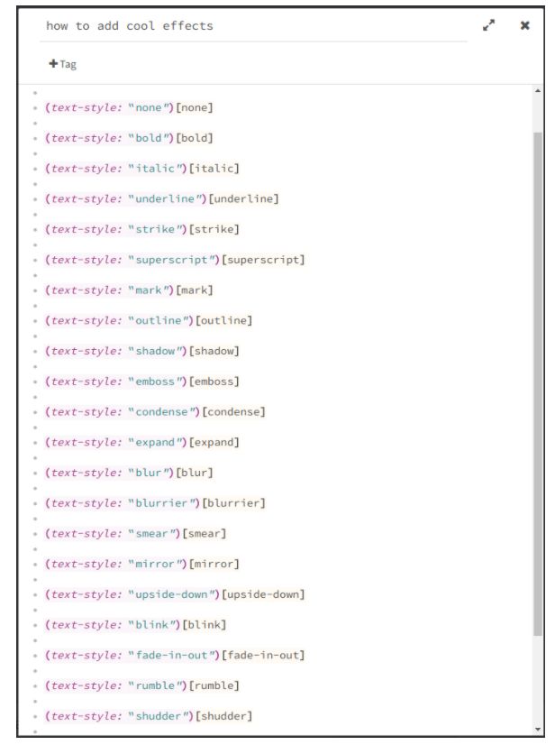

**Using the Stylesheet to Make Changes to the Whole Game**

* You can make larger changes to your game using CSS. Feel free to explore the many, many CSS tutorials available for free online and experiment if you want to customize your Twine game even more.
* To add basic CSS, click on the menu on the bottom left of the screen and click “Edit story stylesheet.”
* To make changes to the overall appearance of your game, you can paste this code into the style sheet:

tw-story {

STUFF YOU WANT TO CUSTOMIZE GOES HERE;

}

* Here is an example of elements that you can customize using the style sheet. Feel free to paste this whole code and make your own tweaks.

tw-story {

font-family: Helvetica;

font-size: 16px;

color: green;

margin-top: 100px;

background-color: grey;

font-weight: 550;

}

* If you want to keep things simple, you can just change the font color and background color:

tw-story {

color: black;

background-color: blue;

}

**Using the Tag Feature to Style Individual Passages**

* You can also use the Tag feature to alter the appearance of individual passages or a group of passages. For instance, let’s say that your game takes place in a haunted house and you would like all of the scenes that take place in the basement to look different than the rest of the game.
* Go to “Edit Story Style Sheet” and paste the following:

tw-story[tags~="insertTAGhere"] {

background-color: insertCOLORhere;

}

This will allow you to change the background color of the tagged passages.

* For example:

tw-story[tags~="Basement"] {

background-color: Gray;

}

* Next, go to the passages that you would like to change, click the “+Tag” option at the top of the box, and type in “Basement.” Now these passages will have a gray background.

**Adding Images**

* Information about adding images, audio, and video taken from this tutorial: <https://twinery.org/wiki/twine2:add_an_image_movie_sound_effect_or_music>
* Video tutorial: <https://www.youtube.com/watch?v=jjpMc8CtPho>
* The simplest way to add images to your Twine game is to use an image that is already available online. Right click on your chosen image, click “copy image address,” and paste that url into your code.
* Add the following to your passage: <img src="the URL of your image">
  + Ex: <img src=" https://hips.hearstapps.com/hmg-prod.s3.amazonaws.com/images/dog-puppy-on-garden-royalty-free-image-1586966191.jpg?crop=1.00xw:0.669xh;0,0.190xh&resize=1200:* ">
* You can customize the image’s size by specifying width and height within the tag:
  + <img src="the URL of your image" width="500" height="300" alt="Text description of your image">
  + For accessibility reasons, you should also add a short text description of your image by using alt="descriptive text"

**Adding Audio**

* <audio src="the URL of your sound effect" autoplay>

**Adding a Video**

* <video src="the URL of your video" width="640" height="480">

</video>

* Like images, you can customize the size your video by adjusting width and height

**Adding Variables**

* Check out this handy tutorial: <https://damonwakes.wordpress.com/2018/01/24/twine-for-beginners-using-variables/>
* In Twine, variables are text with dollar signs in front of them. These variables can be used to store data that will be used throughout the game
* In its basic form, a variable is created or changed using (set: variable to value ).
* For instance, let’s say that you want your player to be able to choose their weapon. You give them two choices: a baseball bat or a knife
  + In the passage after “pick up the baseball bat,” you can use (set: $weapon to bat). Now, whenever you use $weapon throughout the text, the game will display “bat”.
  + In the passage after “pick up the knife” you will use (set: $weapon to knife)
  + Now, whenever you use $weapon throughout the game, the game will display “knife”
* Another, slightly more complicated example: say you want to have your game include a locked door that can only be opened if your player has found a key.

(set: $key to false) At the end of the passageway, you see a door. You try the handle - it's locked. You need to find the key before you can open the door

[[On the ground]]

[[Above the door frame]]

In the “On the Ground” passage:

(set: $key to false) No key down here

Back to [[the door]]

In the “Above the door frame” passage:

(set: $key to true) Aha, there it is!

Back to [[the door]]

In “the door” passage:

(if: $key is true) [You put the key in the handle and it opens! You go [[through the door]]] (else:) [Bummer, you can't get in. Perhaps you should have checked [[Above the door frame]]]

**More Advanced Text Mechanics**

* You can add a browser pop-up dialog box with the given string displayed, and an “OK” button to dismiss it. (alert: “Insert Text”)
  + (alert: "Turn back now!")
  + For a delayed alert, add (live:3s)[(alert: "Run now!")]
* You can make text appear in front of the player's eyes by adding the hook (live:Number)[Text]
  + (live:5s)[This text will appear after five seconds]
  + (live:2s)[This text will appear after two seconds]
* You can add a changer that will make regular text appear after you click on a link. (link-reveal: “Insert visible text”) [Insert revealed text]
  + (link-reveal: "Heart")[ broken]
  + (link-reveal: "You open the door")[ There's nobody there]
  + (link-reveal: "Click me, click me!")[ Haha, fooled you again!]
* The cycling link command makes the text change every time the player clicks on it.
  + (cycling-link: "Mew", "Miao", "Mrr", "Mlem")
  + (cycling-link: "Click me", "Try again", "Too slow!")
* Finally, you can also link to passages without necessarily using the passage name in brackets. This allows you to link multiple passages to the same place without repeating the same text over and over.
  + [[Go to the cellar->Cellar]] is a link that displays the text “Go to the cellar” and takes you to a passage named Cellar
  + [[You run to the back of the house and open a door in the ground->Cellar]] also leads to the passage Cellar, without repeating the same text as the first command.

**Randomizing Text**

* This tutorial is very helpful: <https://damonwakes.wordpress.com/2018/02/01/twine-for-beginners-displaying-random-text/>
* You can have random text display by adding the command (either: “option 1”, “option 2”)
  + (either: “She smiles at you”, “She rolls her eyes at you”)
  + This was the (either: “best”, “worst”) day of your life
  + Note: Like text effects, you will likely need to type this command out yourself, rather than pasting it directly into the passage. You will know it is working when the text changes color.
* You can combine this with the live feature to shuffle text.
  + (live:1s)[(either: "Just click something!", "Hurry up!", "Everyone's waiting!", "Faster!")]

**Playing with Time**

* You can add (current-date: ) to your text so that it displays the current date.
  + You wake up on (current-date: )
* You can also add (current-time: ) to make the game display the current time.
  + It is (current-time: ). You are going to be late